1 The rate of a chemical reaction is the speed at which the reaction goes. The mean rate of a reaction is usually expressed as either the time taken for a quantity of a reactant to be used up or the time taken for a quantity of the product to form. The quantities are usually measured in cm³ or grams.
a) Hydrogen gas is produced when magnesium is reacted with hydrochloric acid. 20 cm³ of hydrogen is produced in 40 seconds. Give the mean reaction rate with units. (2)

Mean reaction rates can also be found by drawing tangents to rate of reaction curves.
Below is one such curve with a tangent drawn at a time of 40 seconds.
b) The rate of reaction is the quickest at the start. Why is this so? (1)

c) Why does the rate of reaction slow down? (1)

d) From the graph above, what is the rate of reaction at the time of 40 seconds? (3)

2 An excess of marble chips was added to 10 cm³ of hydrochloric acid (concentration
1 mol/dm³). The volume of carbon dioxide given off was measured every 30 seconds.
Time in seconds | 0 | 30 | 60 | 90 | 120 | 150 | 180 | 210 | 240 | 270 | 300
Vol. of carbon dioxide in cm³ | 0 | 14 | 23 | 38 | 36 | 40 | 43 | 45 | 46 | 46 | 46
a) Plot the results on the graph paper below with time on the X axis. (4)

b) Draw the best curve possible for these results. (2)
c) Which of the results seems to be wrong? (1)

d) After how long did this reaction stop? (1)

e) What is one way of making this reaction go faster? (1)

f) Draw a diagram of the apparatus you could use for this experiment. (3)

g) How could you investigate the rate of this reaction without measuring the volume of gas produced? (2)

3 Below are five graphs obtained from the reaction of hydrochloric acid (HCl) and solid calcium carbonate (CaCO₃). The reaction produces carbon dioxide gas, water and calcium chloride.
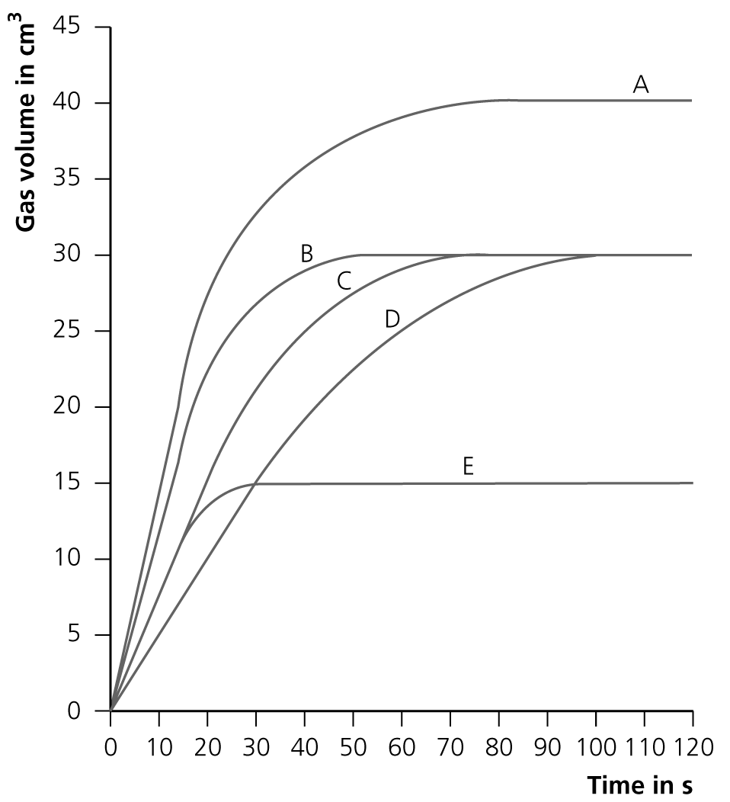
a) Write the word equation for this reaction. (1)

b) Write a balanced chemical equation for this reaction. (4)

Graph C was the result of using 25 cm³ of 1 mol/dm³ HCl and 5 g of medium lumps of calcium carbonate 20°C. The calcium carbonate was in excess.
c) What was the final volume of gas produced? (1)

Which graph would result if the following changes were made:
d) A temperature of 40°C? (1)

e) Larger lumps of calcium carbonate? (1)

f) 12.5 cm³ of acid? (1)

g) Give one explanation of what could have caused graph A. (1)

4 The table below contains results of two experiments showing the rate of reaction between sodium thiosulfate and hydrochloric acid:
 | Experiment 1 | Experiment 2
Concentration of sodium thiosulfate in g/litre | 10 | 20
Temperature °C | 25 | 60
Time to go cloudy | Slow | Quick

The equation for this reaction is:
Na₂S₂O₃(aq) + 2HCl(aq) → 2NaCl(aq) + S(s) + SO₂(g) + H₂O(l)
a) What causes the reaction to go cloudy? (1)

b) Using collision theory, explain why experiment 2 has a quicker rate of reaction than experiment 1. (6)

c) Fill in the gaps in the following:
Catalysts change the rate of _______________ but are not used up during the reaction. ____________ are biological catalysts. Catalysts ___________ the rate of reaction by providing a different __________ for the reaction that has a lower ___________________. (5)
5 Most chemical reactions only go ‘one way’ and are not easily reversed. There are some reactions which are reversible. Their direction can be reversed by changing the conditions.
Ammonium chloride will decompose when heated.
Hydrogen chloride gas and ammonia gas will combine when cooled to form ammonium chloride.
a) Write this chemical equation below: (3)
heat
⇌
cool
When this reaction is done in a sealed container, a state of dynamic equilibrium is reached.
b) What does dynamic equilibrium mean? (2)

Another equilibrium reaction is shown below:
N₂O₄(g) ⇌ 2NO₂(g)
The forward reaction is endothermic.
c) What effect would increasing the temperature have on this equilibrium? (1)

d) What would be the effect of increasing the pressure? (1)

Total = 50

1
a) = 0.5 cm³ s⁻¹ (2)
b) There is the maximum amount of reactant read to react, so highest possible concentration, so faster rate of reaction. (1)
c) The reactants concentration is decreasing, thus less reactant present to react, so decrease rate of reaction. (1)
d) 90 cm³ (3)
2
a) (axis correct way round = 1, label axis = 1, plot all points = 1, curve = 1)
b) Line should be curve (1) missing out 90-second point (1).
c) The result at 90 seconds seems wrong. (1)
d) 240 seconds (1)
e) Use of a catalyst (1)
f)
or collection over water. (3)
g) Use a balance – loss in mass. (2)

3
a) hydrochloric acid + solid calcium → carbon dioxide + water + calcium chloride (1)
b) 2HCl + CaCO₃ → CO₂ + H₂O + CaCl₂ (LHS = 1 mark, RHS = 1 mark, CaCl₂ = 1 mark,
balance = 1 mark )
c) 30 cm³ (1)
d) B (1)
e) D (1)
f) E (1)
g) Increased concentration/volume of HCl (1)
4
a) The production of solid sulfur (1)
b)
Marks
6−5 | At least three different points well expressed
4−3 | A couple of points mentioned
2−1 | Not much detail

- Experiment 2 is at both a higher temperature and increased concentration.
- The increase in concentration means there are more molecules of the reactant present in the solution in a given volume.
- This means there will be more collisions between the reactants and thus more successful collision, meaning a faster rate of reaction.
- The reaction is also at a high temperature.
- This means each of the molecules are at a higher energy, meaning not only do they move faster and thus more collisions, but also that they are more likely to overcome any activation energy needed, so more successful collisions and a faster rate of reaction.
c) reaction; enzymes; increase; route; activation energy (5)
5
a) NH₄Cl ⇌ HCl + NH₃ (LHS = 1 mark, RHS = 1 mark, balance = 1 mark)
b) When both forward and back reactions are happening at the same rate, so no overall changes in concentrations/appears as if nothing is happening. (2)
c) More NO₂ produced, the equilibrium would move to the right. (1)
d) More N₂O₄ produced, the equilibrium would move to the left. (1)
Total = 50

